**­­**

**­­­­­­­**

**LAB # 06**

|  |  |
| --- | --- |
| **SUBMITTED TO­** | **­­­Esha E Noor Durrani** |
| **SUBMITTED BY** | **Muhammad Ayaan Farrukh** |
| **REGISTRATION NO.** | **B24F0488CS035** |

**­**

# **LAB TASK # 01:**

**Write question here.**

print numbers 1-100 using while loop.

**SOURCE CODE:**

|  |
| --- |
| #include<iostream>  using namespace std;  int main()  {      int num = 1;      while (num <= 100){          cout<< num <<" ";          num++;      }  } |

**OUTPUT:**



# ­­­**LAB TASK # 02:**

**Write question here.**

print odd numbers 1-100 using while and do while loop. (1,3,5,7.....99).

**SOURCE CODE:**

|  |
| --- |
| #include <iostream>  using namespace std;  int main() {      int num = 1;      while (num <= 100) {          cout << num << " ";          num += 2;      }      return 0;  } |

**OUTPUT:**

# **LAB TASK # 03:**

**Write question here.**

print even numbers 1-100 using while loop.(2,4,6,8....100)

**SOURCE CODE:**

|  |
| --- |
| #include<iostream>  using namespace std;  int main()  {      int num = 0;      while(num <= 100){          cout<< num <<" ";            num += 2;      }  } |

**OUTPUT:**



# **LAB TASK # 04:**

**Write question here.**

print your formatted name 100 times using while and do while loop.

**SOURCE CODE:**

|  |
| --- |
| #include<iostream>  using namespace std;  int main()  {      int num = 1;      while( num <= 100){          cout<< num <<".Muhammad Ayaan Farrukh ";          num++;      }  } |

**OUTPUT:**

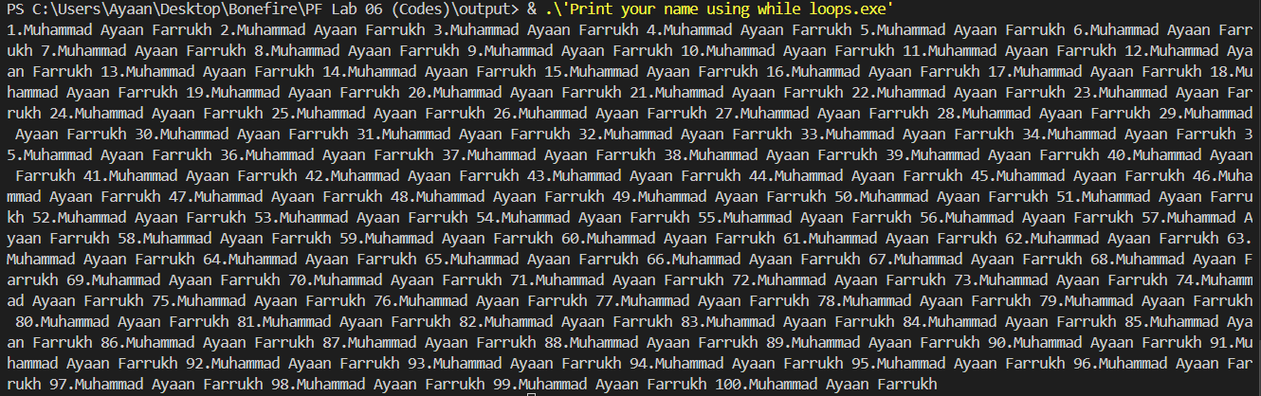

# **LAB TASK # 05:**

**Write question here.**

print factorial of a number using while loop.

**SOURCE CODE:**

|  |
| --- |
| #include<iostream>  using namespace std;  int main(){   int num, factorial = 1;   cout<<"Enter a number for factorial: ";   cin >> num;   int i = 1;   while(i <= num){      factorial *= i;      i++;   }   cout<<"The Factorial of number "<< num << " is: " << factorial << endl;  } |

**OUTPUT:**



# **LAB TASK # 06:**

**Write question here.**

print Fibonacci series using while loop.

**SOURCE CODE:**

|  |
| --- |
| #include<iostream>  using namespace std;  int main (){      int n;      cout<<"Enter the number of terms: ";      cin>> n;      int first=0, second = 1,next, count = 0;      cout<<"Fibonacci Series: ";      while(count < n){          cout<<first<<" ";          next = first + second;          first = second;          second = next;          count++;      }  } |

**OUTPUT:**

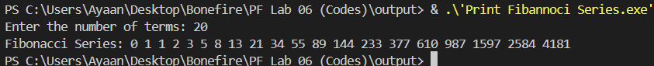

# **LAB TASK # 07:**

**Write question here.**

print table of an number using nested loops.

**SOURCE CODE:**

|  |
| --- |
| #include <iostream>  using namespace std;  int main() {      int number, limit;      cout << "Enter the number to print its table: ";      cin >> number;      cout << "Enter the limit for the table: ";      cin >> limit;      for (int i = 1; i <= limit; i++) {          cout << number << " x " << i << " = " << number * i << endl;      }      return 0;  } |

**OUTPUT:**

